EVOLT/ E-Gym Integration Error Messages

Issue
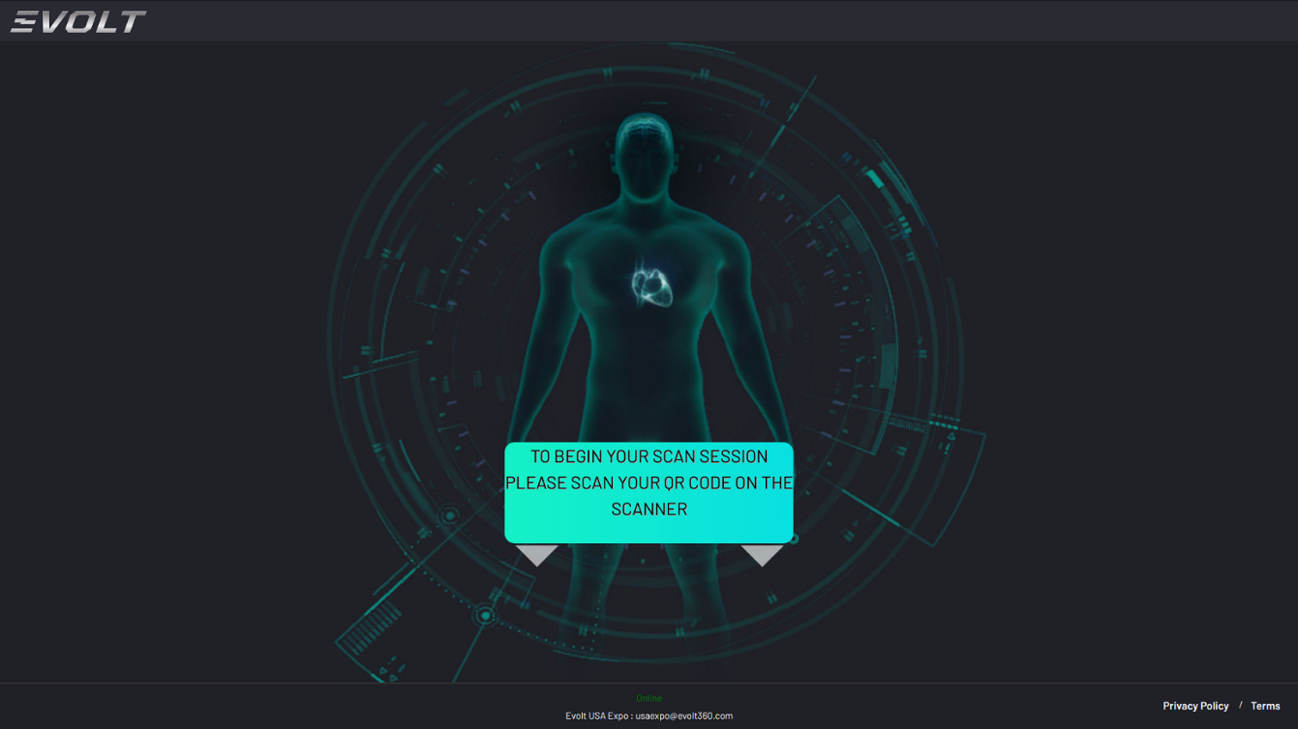
- NFC or RFID Pass not accepting on the EVOLT/ VTAP E-Gym Integration. Once the E-Gym Integration is setup and the VTAP Reader is configured; the user will tap their phone/wallet pass or E-Gym Band to Sign in and Scan.

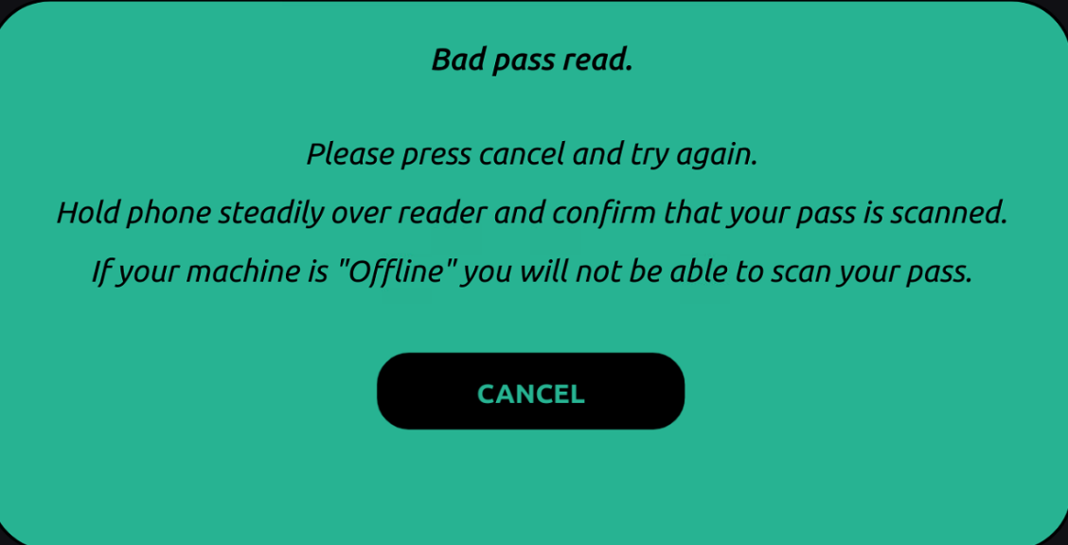
- Error Message – Bad Pass Read
  - Users may get this error message if:
    - Their E-Gym Account is not activated
    - The EVOLT is not connected to the internet
    - The Integration APIs have not yet been setup
      - Check with the insights team to confirm this
    - The VTAP Card Reader has not been configured for the type of NFC or RFID being used
      - Check with EVOLT Support Team to confirm this
    - System or Server Outage from either EVOLT or E-Gym; if all above have been checked report this to EVOLT Head of Support.

